#### Main Character’s (Levi’s) Dorm Room:

Overall, it’s somewhat bare because they are a new (transfer) student. The player can pick a sense of style from a few preset colour palettes. (I’m not sure how involved this is going to be; I don’t know how hard it would be to implement.)

They have a desk and a pencil / ink pen holder; they also have their drumsticks hung up as a wall decor. The notebook on their desk (embossed with an L, the colour of their choosing — default colour is white — as a reference to Death Note) holds the information the character has about the rest of the cast. Initially, it’s the usual spoiler-free otome introduction paragraphs (what the tutorial-NPC RA has said about the cast, as well as a few side characters), but it fills up over the course of the game. They have doodles in the margins; one of these is a drawing of a cog (settings), an icon for the tutorial (maybe a bookmark/book), one is an open door (quit). They keep this notebook with them, so these options are always accessible. There is a doodle for looking at more in-depth character info/notes, and a doodle to look at received mementos/current inventory. There is also a doodle for user-written reminders/important information.

The chair at their desk is a very old one. A lot of their stuff is handed-down or second-hand, because they’re not big on throwing their stuff away as long as it's still functional. They have a small stuffed animal (a well-worn, soft green frog) sitting at their desk when they aren’t. It doesn’t have a name; the player will name them. Their dorm key is hung up on a hook beside their desk. They painted it. Behind the key are their ID from juvie, and a few pieces of woven jewelry — they make bracelets out of twine and tie knots when they’re bored. Their laptop is also old, but functional. There’s a pack of cheap watermelon gum lazily askew on their desk, as if it were thrown to land in the pencil holder, but was just *barely* missed.

They have a snack stash they hide in their desk drawer, full of prison-style snacks they learned to make in juvie. [This character cannot cook - Raiden Shogun!]. The stash is mainly prison-style brownies, saran-wrapped for preservation/storage.

There are a few posters on their walls from their room back home — references to *Badflower, Highly Suspect,* etc. —and a hand-drawn poster of a fictional band called *Garden Variety Disasters*. The drumsticks frame this poster.

There is a cork board on the wall left-side of their desk. It has a calendar. It also has emblem pins and random significant objects that are references and nods to random stuff. There’s a bookshelf where some mementos will go. Others will sit on their desk, or on the windowsill.

There is a switchblade hidden somewhere in their room (canonically for self-defense). Every playthrough, the switchblade is in a different place.

#### Ezekiel’s Dorm Room:

Overall, minimalist, clean, beige, grey, dark colours, white.

Has storage below his bed (his bed is against the wall), textbook spines are visible and readable. His bed is made. There is a teapot half-visible, as if he’s hiding it away. A few books (that aren’t textbooks) have tea bags dangling on the outside; he’s using unused teabags as bookmarks (as if he needed a bookmark and thought, *this’ll work.)* — when he’s done with the book, he has a cup of tea. What is not visible is his film equipment or any portfolios. Equipment is likely in a lockbox, and his portfolios are in a locked briefcase under his desk.

He has one of those fuzzy, white bucket reader chairs at his desk, it’s a bit big because he’s rather tall.

There’s a teacup or mug on his desk. He has a stone owl as a paperweight for homework or notes he’s in the middle of. He’s one of those pretentious fucks that has candles in his room (petrichor). His bag is usually placed against the wall, in front of the end of his bed.

Has polaroid photographs hung up on the wall; some are (meta) photos of cameras. Others are photos of things in motion, frame by frame — a burning cigarette, a pencil falling off a desk, a flickering letter on a motel’s ‘We’re open’ sign, a butterfly flexing its wings. Beside or underneath these photos are titles/notations in French. Other photos: of Harper’s sunflower field; he stumbled upon it. Of graveyards, of an indeterminable wooden object (probably a wooden burning man, tbh) burning in an empty parking lot. Of himself right after The Incident. At first glance, he looks happy to the point of tears.

Background theme is classical music; probably from a small bluetooth speaker that’s sitting on a deck of cards that’s on his desk. The speaker is sitting beside the owl. The desk is tiered, the second tier isn’t exactly an entire shelf; it has enough space for a teacup and miscellaneous items, namely an indoor orange tree that brings a spot of bright colour to an otherwise understated room. An unplayed viola leans against his desk, has a support frame so it won’t be damaged.

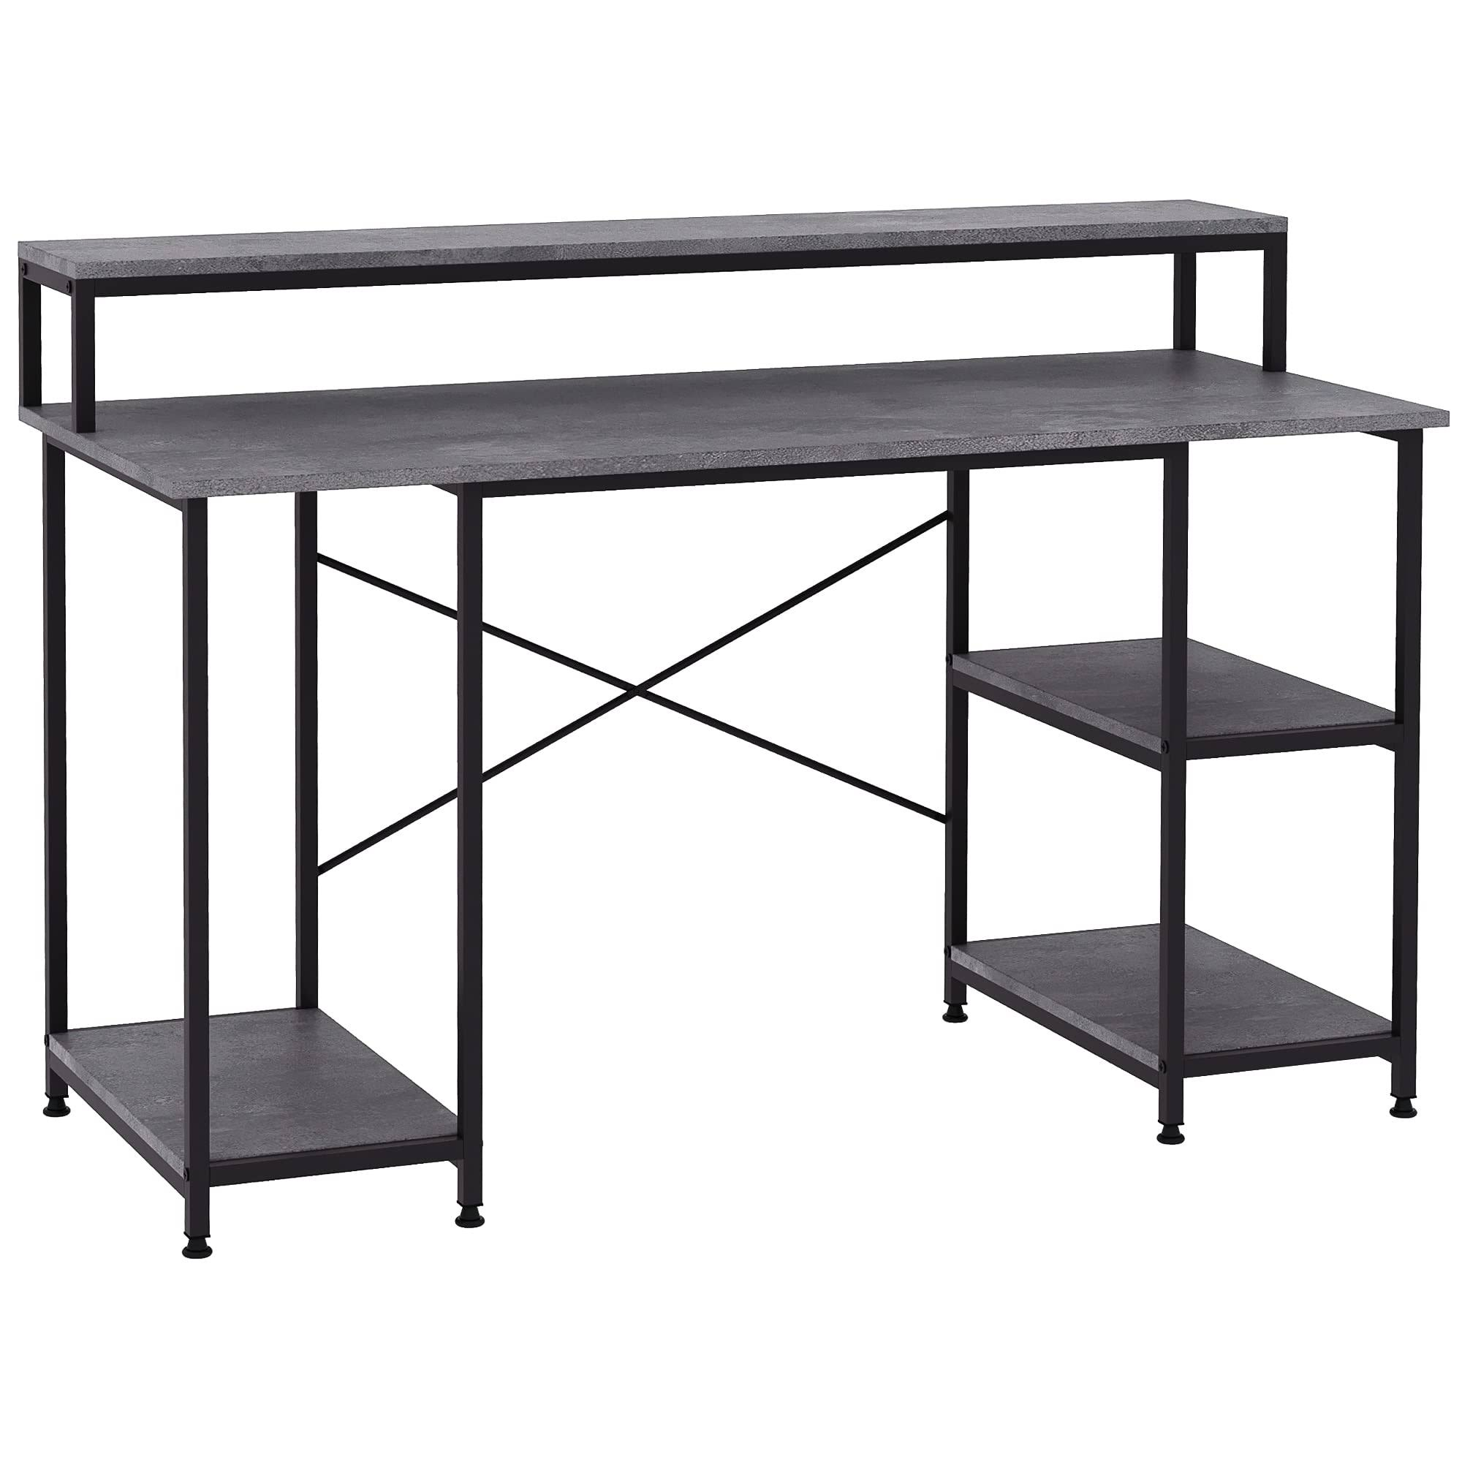

##### Ezekiel’s Mementos

The Viol

Briefcase - Persona 5 - “sole interest is uncovering the truth”

Deck of Cards - Royalty - Mumford and Sons *Broken Crown*

The Butterfly Effect photograph - *Life Is Strange* reference

A reference to Welt Yang and Mona Megistus - A golden globe / a gold “Cosmos Within” Genshin Impact Furnishing

An orange from the small, personal-sized orange tree on his desk - Reference to [Gangplank](https://leagueoflegends.fandom.com/wiki/Gangplank/LoL#Remove_Scurvy) and the ‘I ate oranges and it was ‘kay,’ meme from League.

#### Harper’s Dorm Room

Overall, her room has a method to its madness, haphazardly organised, pastel colours, very “i think i mostly want to see what happens when this whole place breaks apart.”  
  
Her room isn’t messy so much as it’s chaotic and all over the place just like her. Her bed, however, is scarily pristine, as if she makes it with precision every morning, or as if it was never slept in at all. She has fairy lights hung around the room, and her bed has one of those fancy sheer curtains around it (canopy bed). Her bookcase is above her desk; it holds a bunch of fantasy novels. Her desk has a pull-out panel under it, with a built-in (but removable) keyboard.

On her nightstand is a digital diary with a PIN. It’s her birthday, but no one knows her birthday. Her father gave it to her. She also has a diary she physically writes in. She has more tech than the other students because of her father’s line of work and pulling strings to arrange her being at the school. She can handle technology and audio in her sleep.  
  
Her closet is full of clothes of various styles -- some stolen from the costumes closet from the theatre. Her window spills light above her bed (hence the canopy). She has knick knacks on her windowsill. She has one or two plants in her room. They’ve died. She can’t remember to water them (or take them out of her room, for that matter). [They’re labelled *Anxiety* and *Overthinking,* respectively.](https://www.boredpanda.com/blog/wp-content/uploads/2018/04/icarus-and-sun-love-story-gabriel-picolo-5ac5f20c2e4a3__880.jpg) She has sheet music on her desk, along with a small game of never-ending Go -- when she’s asked about it, she comments she’s never been able to win a game, ever. She has a computer that she uses for audio work, and for watching content. Often, there’ll be something playing onscreen or music playing, but she isn’t in her room most of the time. Her chair doesn’t have very good back support, but it looks cute.

She has bean bag chairs for other people to sit in, and often plays catch with an eggplant pillow that she keeps under a spot on her wall that says ‘aubergenius.’ She’s named the eggplant Violet. She secretly makes playlists for the other characters. She has one for herself (meta :3).  
  
Origami cranes and other origami animals are littered around her room, and hanging from her bed outside the canopy— usually made out of sheet music of abandoned songs or poems.

Her bed (and/or computer monitor, and/or the lock on the digital diary, haven’t decided) has a small port on its edge, but is unnoticeable for the most part. Ezekiel is the only one that has noticed, but has said nothing. Everyone assumes they’re for some overly techy shit, and, technically, (hah) they’d be right.

On her walls are strips of paper -- of random sentences of various colours, quotes and phrases and sticky note reminders or just random things she’s heard that have stuck in her brain. Her walls are just one giant blackout poem, basically (that changes on a whim).

She has a small calendar -- but instead of appointments, every day of the month has a song associated with it, and a self-affirmation, written in coloured pencil.  
  
Background music is lo-fi or instrumental game music. Probably from her computer.

She is visibly uncomfortable when in her own room, and doesn’t like others in her room, either. If she happens to be in her room, she’ll ask you for a password. There is no password.

##### Harper’s Mementos

Go Piece - a reference to TRON 2

Eggplant Pillow - Bee and Puppycat reference

A halfway painted-blue Princess Daisy on her nightstand - A simultaneous triple-threat reference to Ashnikko’s *Daisy 2.0,* Hatsune Miku, and Mario

A paper sparrow and a paper robin, sitting side-by-side, both made of sheet music.

A space-themed d20 and a die with snake eyes - Dimension20 reference and a reference to Slothrust’s *Double Down*, respectively.

One randomized item that references real-world media.

#### Liastra’s Dorm Room

Overall,

##### Liastra’s Mementos

#### The Twins’ Dorm Room

Overall, their room is two extremes. Will’s side is hyper-organized, almost at odds with a coolly disheveled appearance. Aiden’s side is lazily messy, where he takes care of his appearance to ensure it comes off as effortless. They’re not dirty or unclean — it’s just *very clear* that two teenage boys live in this room. There’s no computer in their room; they have no need for one. The room smells faintly of smoke, ash, and salt. Both twins swim, Aiden more than Will. Will practices shooting his gun behind the school, more out of self-defense than a hobby.

##### Will Vale

Will studies art and sketches/draws a lot. He also works backstage as the makeup artist. He has a few sketches hung up on his side of the room. There is a purple notebook on his nightstand. His bed is made, almost perfectly — if not for the fact that his (thin) blankets are usually hanging off the edge of the bed. His bookshelf is full of textbooks, but he’d never let anyone see. He uses failed drawings as bookmarks. He rolls his clothes so they take up as little space as possible. His side of the bathroom has hair gel, a comb, and a toothbrush.

They have a small area for playing chess on the floor, the board’s various pieces slowly stolen from the library. Some of the pieces are small, ceramic foxes; Liastra made them for an (oblivious) Will.

On one of two chairs in the room is Will’s leather jacket, dark brown, almost black fingerless gloves in its seat. The other chair has a green scarf wrapped around its middle like a shitty, pompous NY-Fashion-Week belt.

##### Aiden Vale

Aiden does woodcrafting and he works on props. He creates wooden-figurine animals with a small dagger.

The twins work together to create the scenes for the school’s theatre productions.

His side of the room has a wooden dartboard; he throws knives. It’s honestly surprising that either of them haven’t been suspended yet — or it would be if they weren't charming, mischievous, sneaky little shits.

They nearly went to prison, and commemorate that achievement with fake prison numbers over their headboards. Above their respective numbers are “As above,” and “So below,” respectively [*Neverwhere*]. Above those are a yellow sun and a purple moon [Prospit/Derse Homestuck reference].

##### The Twins’ Mementos

##### Will’s Mementos:

[Icarus Reference / EDEN song reference]

[Brown fingerless gloves - *The Shannara Chronicles*]

[A reference to The Outsiders - hair gel / the burning ember quote in the flavor text]

[A charred black king piece - Code Geass / Prince Zuko]

[Christopher Pierre???]

[A scream reference - Corn Syrup]

##### Aiden’s Mementos:

[Stardew Rabbit’s Foot]

[?????]

[arrow - half alive???]

[Beyond: Two Souls reference]

[Stone Wolf]

[La La Land Reference]

#### Eva’s Dorm Room

Overall, her dorm room looks like a mess, and it honestly very much is to anyone except her. It is evident to everyone that she has a mind that is constantly firing on all cylinders, for better or for worse.